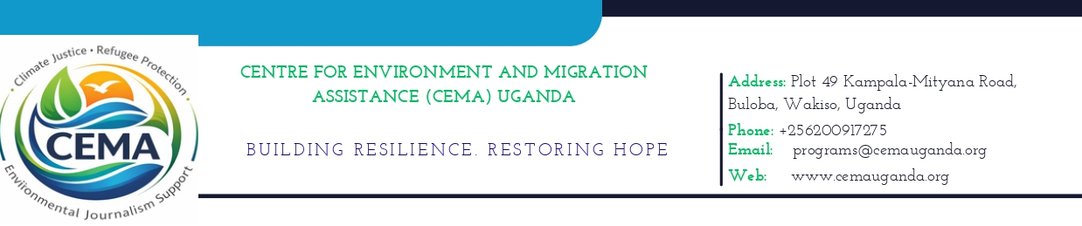

CALL FOR PROPOSALS

Grassroots Climate Action Fund (GCAF)
The Centre for Environment and Migration Assistance(CEMA) invites applications from grassroots and community-based organizations for its Climate Justice Small Grants under the Grassroots Climate Action Fund (GCAF).

Background
Climate change continues to disproportionately affect vulnerable and frontline communities, particularly women, youth, and marginalized groups. Despite this, these communities often have limited access to resources needed to respond effectively.
Through the Grassroots Climate Action Fund, CEMA seeks to support locally driven, innovative, and impactful initiatives that advance climate justice, environmental accountability, and community resilience.

Objective of the Call
The Call for Proposals aims to:
- Support grassroots climate justice initiatives
- Strengthen community-led environmental accountability
- Amplify voices of marginalized and frontline communities
- Promote inclusive and gender-responsive climate action
- Encourage innovative local solutions to environmental challenges

Who Can Apply
Applications are open to:
- Community-Based Organizations (CBOs)
- Women-led groups
- Youth-led initiatives
- Grassroots civil society organizations
- Local environmental justice movements
Unregistered groups may apply but must demonstrate legitimacy and community support.

Priority Areas
Proposals should align with one or more of the following:
- Climate adaptation and resilience
- Environmental accountability and transparency
- Community environmental monitoring
- Climate finance tracking
- Protection of ecosystems (wetlands, forests, biodiversity)
- Gender-responsive climate action

Grant Size and Duration
- Grant size: USD 1,000 – 5,000
- Project duration: 3 to 12 months

Eligible Activities
- Community awareness and mobilization campaigns
- Environmental monitoring and reporting
- Advocacy and accountability initiatives
- Local climate adaptation actions
- Capacity building and training
- Community-led conservation efforts

Application Process
Applicants should:
- Download the Proposal Template and Budget Template
- Complete all required sections
- Submit both documents, along with organization details
📧 Email to: programs@cemauganda.org
📌 Subject line: GCAF Application
Note: Only shortlisted applicants will be contacted.

Required Documents
- Completed Proposal Template
- Completed Budget Template
- Proof of registration (if applicable)
- Supporting documents (optional but encouraged)

Selection Criteria
Applications will be assessed based on:
- Relevance to climate justice and environmental accountability
- Feasibility and clarity of proposed activities
- Community ownership and participation
- Inclusion of women, youth, and marginalized groups
- Sustainability and potential impact
- Budget clarity and value for money

Reporting Requirements
Successful applicants will be required to submit:
- Mid-term progress report
- Final narrative and financial report
- Supporting documentation (photos, receipts, activity records)

Deadline for Submission
🗓 Deadline: Ongoing

Contact for Inquiries
For questions or clarifications, contact:
📧 programs@cemauganda.org

CEMA encourages applications from women, youth, and underserved communities, and strongly promotes inclusive, locally led solutions to climate and environmental challenges.
Downloadable Resources
- GCAF Proposal Template (Link)
- GCAF Budget Template (Link)
- GCAF FAQs (Link)

